**※ Prolog 소스코드 및 실행결과**

1.

① 소스코드

|  |
| --- |
| man(marcus).  pompeian(marcus).  born(marcus,40).  mortal(X):-man(X).  erupted(volcano,79).  died(X,79):-pompeian(X).  /*No mortal lives longer than 150*/  dead(X,T2):-  mortal(X),  born(X,T1),  T2-T1 > 150.  /*If someone died, then he is dead at all later times*/  dead(X,T2):-  died(X,T1),  T2 > T1.  /*Alive means not dead*/  alive(X,T):-  not(dead(X,T)).  not(alive(X,T),dead(X,T)). |

② 실행결과

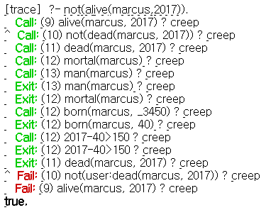

2.

① 소스코드

|  |
| --- |
| man(marcus).  pompeian(marcus).  roman(X):-pompeian(X).  ruler(ceasar).  try_assassin(marcus,ceasar).  /*All Romans were either loyal to Ceasar or hated him*/  %roman(X) -> hate(X) or loyal(X)  not(roman(X),not(loyal(X,Y)),not(hate(X,Y))).  %not(roman(X) -> (hate(X) and loyal(X))  hate(X,Y):-  roman(X),  not_loyal(X,Y).  /*Everyone is loyal to someone*/  loyal(X,loyal_of(X)).  loyal_of(X):-  loyal(X,_).  /*People only try to assassinate rulers they are not loyal to*/  not_loyal(A,B):-  ruler(B),  try_assassin(A,B).  not_loyal(A,B):-  not(loyal(A,B)).  not(not_loyal(A,B), loyal(A,B)). |

② 실행결과

2-1.

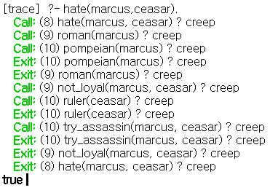

2-2.

